P R P R EG EN E R A T I O N

DR. MIKHAIL ARTAMONOV

Platelet Rich Plasma or PRP is a groundbreaking innovation in regenerative medicine. The treatment uses the patient’s own (autologous) blood drawn and separated to create a concentrate extremely rich in platelets, which is injected into a treated area of the body to trigger or accelerate the body’s own healing and regenerative response.

The patient’s blood is first drawn, then centrifuged to separate the red blood cells and plasma, leaving a concentrate of platelets, white blood cells and stem cells. Once activated, the platelets and stem cells release several powerful growth factors that are responsible for healing tissue.

While the normal platelet count in whole blood is about 200,000/microliter, PRP has concentrations of 1,000,000-2,000,000 platelets/microliter. Since such a concentration does not occur naturally, the injection of Platelet Rich Plasma into the body has a powerful therapeutic effect. In essence, PRP dramatically accelerates the body’s own healing and regenerative processes by amplifying the effects of the growth factors.

Since the PRP treatment uses the patient’s own blood which neither can be rejected by the body nor cause harm to it, there are no adverse effects of PRP. In some cases some patients may experience a mild soreness in the treated area, which can be easily managed with a regular pain relief medication.
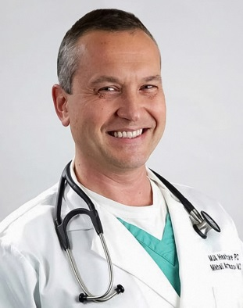
Dr. Mikhail Artamonov, M.D. graduated from the Texas College of Osteopathic Medicine. He is certified in Muskculoskeletal Sclerotherapy (Prolotherapy) by the American Board of Sclerotherapy. His training in Prolotherapy is extensive, having trained with Gustav Hemwall, MD in the early 1990’s, as well as training from the American Academy of Orthopedic Medicine, and the American Osteopathic Association of Prolotherapy Regenerative Medicine.

Dr. Artamonov is a board member and lecturer for the American Osteopathic Association of Prolotherapy Regenerative Medicine and a clinical instructor/ preceptor for medical students and residents from the University of North Texas. He has also done extensive training in Neural Therapy with world renowned Dietrich Klinghardt, MD, PhD, and uses Neural Therapy in conjunction with Prolotherapy to maximize patient results.

In his practice Dr. Harris utilizes PRP, Neural Therapy, Prolotherapy, adult autologous stem cell therapy, nutritional supplementation, and other complementary modalities. He is a member of the American Association of Orthopedic Medicine, American College for the Advancement of Medicine, International College of Integrative Medicine, and American Board of Clinical Metal Toxicology.
Hair Regeneration

PRP can be effective in treating the following conditions:
•

- Male pattern hair loss – especially in the early stages of balding, or when there is a lot of miniaturized hair on the scalp
- Female pattern hair loss – in all stages
- Hair loss due to metabolic causes, such as iron deficiency or caused by medication
- Alopecia Areata, Alopecia Totalis

What science has to say
“PRP injection is a simple, cost effective and feasible treatment option for androgenic alopecia, with high overall patient satisfaction.”
“A significant reduction in hair loss was observed between first and fourth injection. Hair count increased from average number of 71 hair follicular units to 93 hair follicular units. Therefore, average mean gain is 22.09 follicular units per cm2.” (1)
“The data clearly highlight the positive effects of PRP injections on male pattern hair loss and absence of major side effects. PRP may serve as a safe and effective treatment option against hair loss; more extensive controlled studies are needed.” (2)
“In conclusion, intra-perifollicular injections of autologous PRP and/or PDRN generate improvements in hair thickness and density in FPHL patients.” (3)

PRP Breast Augmentation

Although it will not double your cup size, PRP Breast Augmentation is an alternative to surgical implants. It has been reported to:
• reshape and round up the breasts
• lift up saggy breasts
• improve the shape and contour of cleavage
• eliminate stretch marks
• correct inverted nipples
• increase the sensitivity of breasts and nipples

In addition, PRP Breast Augmentation has been proven effective in correcting rippled breast implants.

How it works
First, blood is drawn from the patient’s arm, then the blood is then centrifuged to obtain a Platelet Rich Plasma, rich in growth factors. This PRP is then mixed with plasma proteins from the same blood draw and injected into the breasts. The procedure takes about 15 minutes. The level of discomfort is similar to having blood drawn or getting any other cosmetic injections. There is no downtime and the results are noticeable within a few days. It takes about two months for the full results. The results last a year or longer, and in some cases can be permanent.

(1) Platelet-Rich Plasma in Androgenic Alopecia: Myth or an Effective Too. Swapna S Khatu, Yuvraj E More, Neeta R Gokhale, Dipali C Chavhan, and Nitin Bendsure J Cutan Aesthet Surg. 2014 Apr-Jun; 7(2): 107–110
(2) The Effect of Platelet-Rich Plasma in Hair Regrowth: A Randomized Placebo-Controlled Trial. Gentile P, Garcovich
S, Bielli A, Scioli MG, Orlandi A, Cervelli V. Stem Cells Transl Med. 2015 Nov;4(11):1317-23.
(3) Therapeutic efficacy of autologous platelet-rich plasma and polydeoxyribonucleotide on female pattern hair loss.
Lee SH, Zheng Z, Kang JS, Kim DY, Oh SH, Cho SB.

O-Shot®

While research shows that 25% to 45% of women in
North America suffer from urinary incontinence, and/ some form of a sexual disorder, these common problems are seldom addressed or treated. But there a simple solution. O-Shot® is a patented procedure oven effective in treating both urinary incontinence d stress incontinence, as well as rejuvenating female orgasm system and improving sexual response.

Although the individual experiences vary, the usual results of the treatment include:

• Decreased urinary incontinence
• A tighter vaginal opening
• Younger, tighter skin of the vulva (lips of the vagina)
• Increased natural lubrication
• Greater arousal
• Increased sexual desire
• Stronger and more frequent orgasms
• Increased ability to have a vaginal orgasm
• Decreased pain in case of dyspareunia (painful intercourse)

How it works
The blood is drawn from the patient’s arm. The blood is then centrifuged to obtain a Platelet Rich Plasma, rich in growth factors. The PRP is then injected using a tiny needle into the clitoris and upper vagina — the area known as the O-Spot. Since this area has been numbed with the anesthetic cream prior to injection, there is very little to no pain. The entire procedure takes about 10 minutes.

The procedure is protected by US Patent & Trademark Law - number 85270524.
The Priapus® Shot / P-Shot

Priapus® Shot is a procedure designed to treat erectile dysfunction, improve sexual response, and rejuvenate the male sexual organ. The usual results include:
• Improved and longer lasting erections
• Larger, stronger and straighter penis
• Increased sensation and pleasure
• Customized size increase; the base or the head
•Better response to therapies such as Viagra or Cialis
How it works
The blood is drawn from the patient’s arm. The blood is then centrifuged to obtain a Platelet Rich Plasma, and treated with calcium chloride solution to activate the growth factors. The PRP is then injected using a tiny needle into the penis. Since the penis has been numbed with the anesthetic cream prior to injection, there is very little to no pain. The entire procedure takes about 10 minutes.
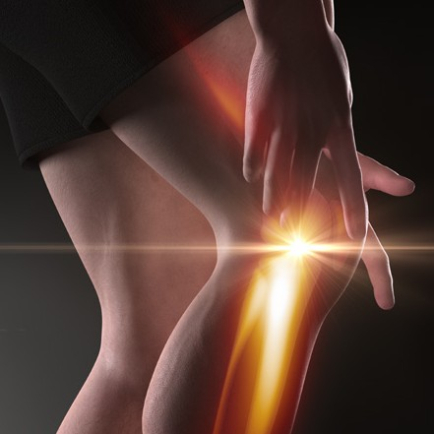PRP Musculoskeletal Injections

PRP injections are used in sports medicine in the treatment of injuries of ligament, tendon, muscle and joint. Traditional therapies do not address the problem of the naturally poor healing properties of connective tissue, nor stimulate muscle recovery, while some can cause serious adverse effects. In contrast, PRP injections stimulate and enhance the body’s natural healing processes and can shorten healing time.

What injuries can be treated with PRP
• Tennis elbow (common extensor tendinosis)
• Golfer’s elbow (medial epicondylitis)
• Jumper’s knee (patellar tendinosis)
• Achilles tendinosis
• Plantar fasciitis
• Hamstring injuries
• Groin pull injuries
• Ankle sprains
• Whiplash injuries

• Quadriceps tendon injuries
• Rotator cuff damage
• Knee sprains
• Knee osteoarthritis
• Hip Osteoarthritus
• Low back pain
• Cervicalgia, (neck pain)
• TMJ dysfunction
• and many more

How it works
The blood is drawn from the patient’s arm. The blood is then centrifuged to obtain a Platelet Rich Plasma, rich in growth factors. The PRP is then injected into the injured area to stimulate healing. The procedure takes about 45 minutes, depending on the specific injury, typically 3, or sometimes more, treatments are required, 6 to 8 weeks apart.

PRP Facial Rejuvenation

As we age the facial skin becomes more saggy, rough and creased, and the skin color becomes more ashen. While quality cosmetics and facials help improve the appearance, they do not address the underlying causes, nor provide lasting results. A multitude of case studies throughout the world have demonstrated PRP’s effectiveness in rejuvenating facial aging and reducing moderate wrinkles. The procedure initiates and enhances the body’s own natural rejuvenating abilities. It stimulates collagen growth, leaving the skin refreshed, glowing and smoother. An improvement of skin texture and tone can be noticeable within 3 weeks.

How it works
The blood is drawn from the patient’s arm. The blood is then centrifuged to obtain a Platelet Rich Plasma, rich in growth factors. The PRP is applied topically and driven into the skin using a micro-needling device which creates multiple micro-punctures through the skin. PRP soaks in to stimulate skin tightening and rejuvenation. The entire procedure takes about 45 minutes. As the healing progresses, the skin tightens and the result is a naturally glowing, youthful skin appearance. Results are noticeable in 2 to 3 weeks.

PRP REGENRATION

570-872-9800

391 East Brown St
East Stroudsburg, PA

www.MJAHealthCare.com

The information in this brochure is for educational purposes only. Neither statements nor treatments involving platelet rich plasma or stem cell therapy have been evaluated by the FDA. The statements contained herein do not claim that these treatments work for any listed or unlisted condition. Individual results will vary and they are neither guaranteed nor warranteed.
When considering a specific treatment, consult your physician.

